Anthony Sevarino

EET 2141

Fall ‘24

**Lab 4: Diode Applications – Zener Diode, Voltage Regulator, and Limiter**

**Introduction:**

The objective of this lab is to analyze diodes, specifically their interactions and behaviors within a Zener diode circuit, and a Zener voltage regulator. Thus, a critical focal point of the lab is observing the Zener diode effect on the operation of a voltage regulator and limiter. A Zener diode circuit does not contain a normal diode, which usually does not allow current to flow in reverse bias, and instead contains a Zener diode, which works in the breakdown region when in reverse bias and will maintain constant voltage with a varying Zener current rating. A Zener voltage regulator can be used for many things, such as smoothing unwanted ripple voltage down to constant dc output. This occurs due to the aforementioned behaviors of the Zener diode, which will maintain a voltage level up to a certain current.

**Bench Parts and Equipment List:**

|  |  |  |  |
| --- | --- | --- | --- |
| ***Components*** |  |  |  |
| • | 1kΩ Resistor | • | 1N4733 Zener Diode (2x) |
| •  ***Equipment*** | Numerous Connector Wires |  |  |
| • | Programmable DMM | • | ELENCO Trainer Board |
| • | Triple Power Supply | • | Windows Machine w/  Multisim |
| • | DS1102E Digital  Oscilloscope and Probes | • | Function Generator |

**Discussion:**

# Part 1 – DC Zener Diode Circuit

It is important to understand the purpose and function of a Zener diode in a circuit as opposed to a regular diode. Instead of completely or mostly blocking current from passing through when in reverse bias, a Zener diode will allow regular current and voltage through up to a certain breakthrough point, wherein the diode will then limit such voltage to the boundaries of its own constraints. In forward bias, a Zener diode functions identically to a regular diode.

The first step of this lab is to construct, in Multisim, a simple DC Zener diode circuit, with a 1kΩ resistor in series, and a direct voltage source of varying values in series. Then, the circuit is to be observed for theoretical behavior of the circuit without varying resistor values or inconsequential smaller internal resistances of certain pieces of equipment, such as those found within the DMM, the function generator, or the triple power supply. Below is the constructed circuit for part 1 of the lab:

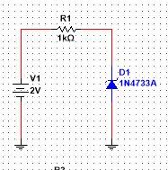

*Figure 1 - Circuit 1 Constructed on Bench*

Note the orientation of the Zener diode, in reverse bias. Thus, this circuit will theoretically build voltage up to the limit of the Zener diode (around 5.1v for this particular Zener diode).

To calculate, theory-wise, the ideal and practical Zener current and voltage, utilize the following formulas:



$$I_{z}\left(ideal\right)=\frac{V_{in}-V_{z}}{R}$$

$$I_{z}\left(practical\right)=\frac{V_{in}-V_{out max}}{R}-\frac{V_{in}-V_{out min}}{R}$$

$$V_{z}\left(ideal\right)= V_{z}≤V_{in}$$

$$V_{z}\left(practical\right)=V_{z}+\left(I_{ZM}-I_{z}\right)Z_{z}$$

Now, construct the circuit on the bench for real world measurements, then compare these measurements to the theoretical calculations obtained using the aforementioned formulas:

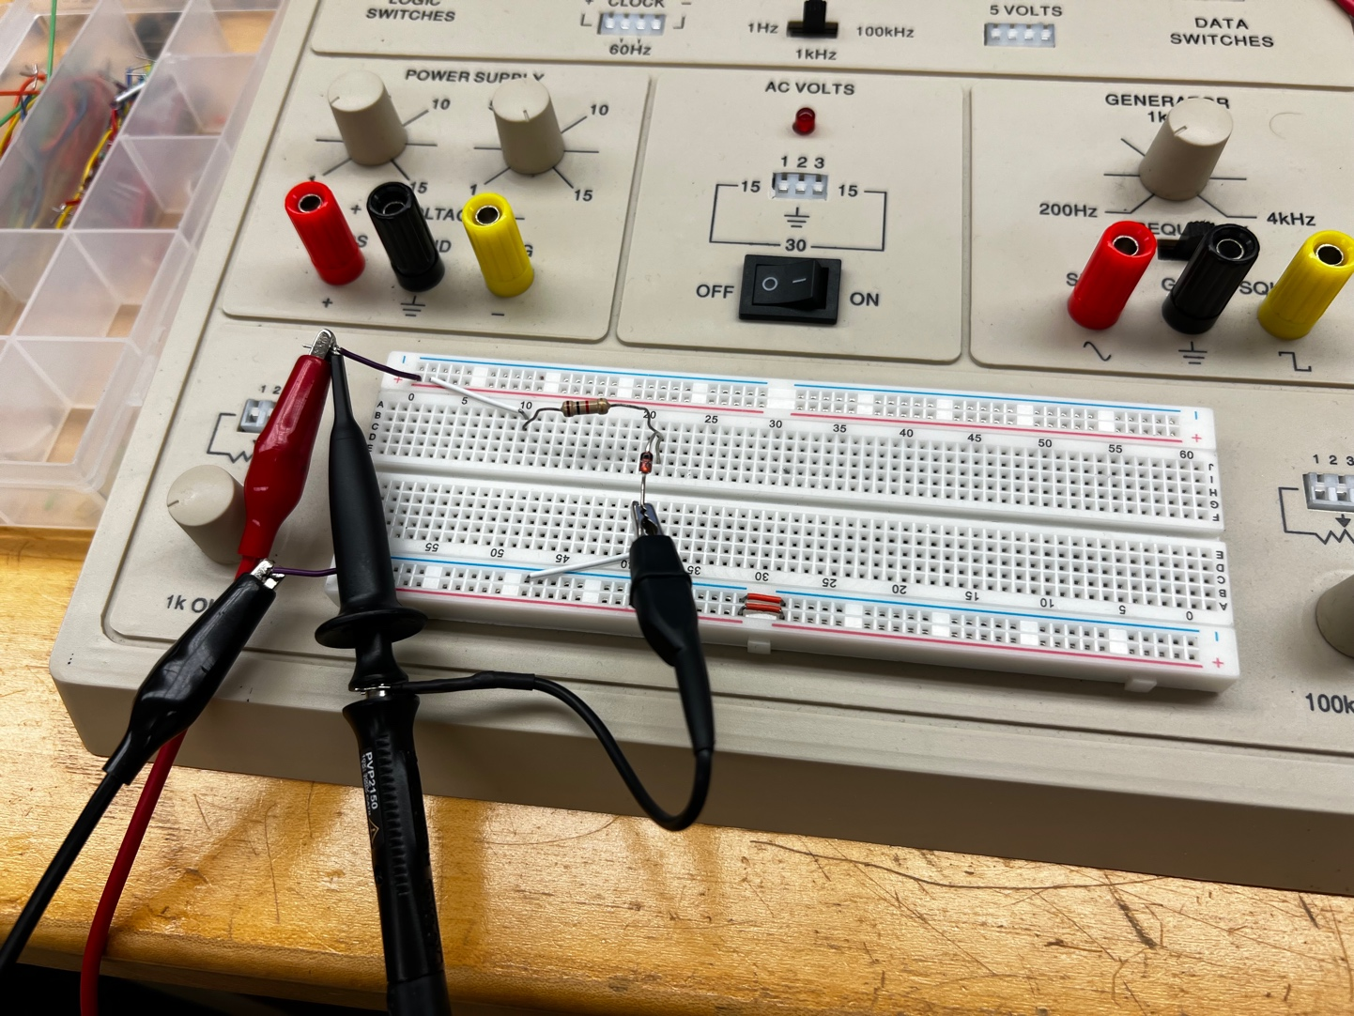

*Figure 2 - Circuit 1 Constructed on Bench*

*(oscilloscope irrelevant as used for measurement in next part)*

After taking the measurements on the bench, the following table is filled with all calculated and measured values:

**Table 1 – Zener Current and Voltage against Input DC Voltage**

|  |  |  |  |  |  |  |
| --- | --- | --- | --- | --- | --- | --- |
| **Input**  **DC Voltage** | **Zener Current**  **(mA)** | | | **Regulated Voltage (Zener)**  **(V)** | | |
| **(V)** | **Calculated**  **(Ideal)** | **Calculated**  **(Practical)** | **Measured** | **Calculated**  **(Ideal)** | **Calculated**  **(Practical)** | **Measured** |
| **2** | 0 | 0 | 0.75µ | 2 | 2 | 2.03 |
| **3** | 0 | 0 | 36.5µ | 3 | 3 | 3.05 |
| **4** | 0 | 0 | 304.00µ | 4 | 4 | 3.76 |
| **4.5** | 0 | 0 | 517.90µ | 4.5 | 4.5 | 3.97 |
| **5** | 0 | 0 | 833.3µ | 5 | 5 | 4.15 |
| **5.5** | 0.4 | 0.4 | 1.20 | 5.1 | 5.08 | 4.27 |
| **6** | 0.9 | 0.88 | 1.56 | 5.1 | 5.08 | 4.37 |
| **6.5** | 1.4 | 1.39 | 1.92 | 5.1 | 5.08 | 4.44 |
| **7** | 1.9 | 1.85 | 2.40 | 5.1 | 5.08 | 4.49 |
| **8** | 2.9 | 2.82 | 3.19 | 5.1 | 5.08 | 4.58 |

# Part 2 – Voltage Limiter Circuits

As previously discussed, a voltage limiter circuit uses Zener diodes to limit either or both levels of an AC signal to any DC level. For example, a Zener diode with a Zener value of 5.1 volts will pass 2 volts from a 2 volt incoming signal, but 5.1 volts to anything above a 5.1v signal.

Below, an example of a voltage limiter circuit is constructed in Multisim, using an AC voltage source, a resistor, and a Zener diode, all in series (as per the specifications set by the lab manual):

*Figure 3 – Part 2 Voltage Limiter Circuit 1 Constructed in Multisim*

Note that in this, and each of the upcoming Multisim circuits, the *Default Oscilloscope* digital device is used to measure the AC input and output signal.

*Figure 4 – part 2 Voltage Limit Circuit 1 Simulation Waveform*

Also note that increasing the input voltage to 7 Vp slightly increases the max and min of V of the output channel, in other words, Voutp increases. Below is a representation of Vin and Vout at 8 Vp superimposed over one another:

*Figure 5 – Part 2 Circuit 1 MATH waveform*

Building this circuit on the bench is shown in the following figure: note the oscilloscope probe placements for properly measuring necessary values:

*Figure 6- part 2 Voltage Limiter Circuit 1 Constructed on the Board*

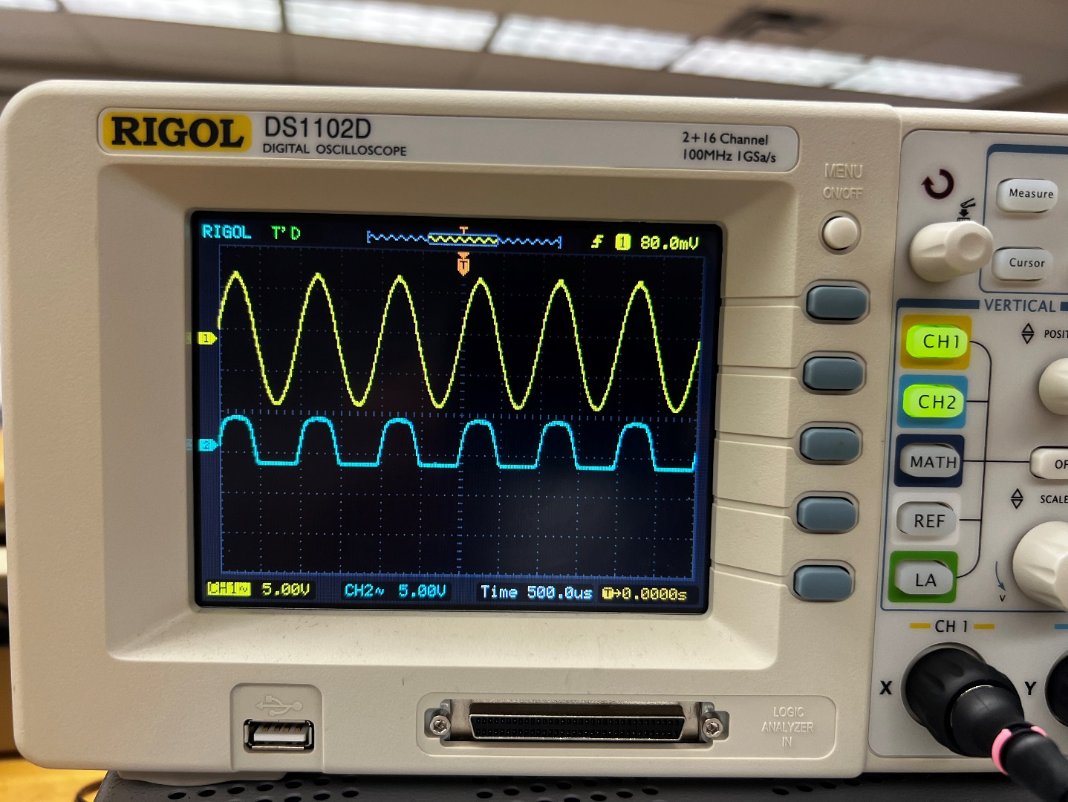

*Figure 7- Resulting Waveform of Circuit 1 of Part 2*

Measuring The arithmetic difference of Vin and Vz yields the following value for Vr (conducted using the MATH function on the oscilloscope and setting the mode to A-B):

$$V_{r}=16.4v$$

Next, the diode is to be reversed such that the behavior of a Zener diode in forward bias can be observed:

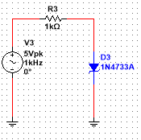

*Figure 8- Part 2 Multisim Construction of Voltage Limiter Circuit 2 (forward-bias)*

Thus, the construction of the circuit on the bench is as follows. Again note the placement of the oscilloscope probes for taking the proper measurements:

*Figure 9- Part 2 Circuit 2 Simulation Waveform 2 (forward-bias)*

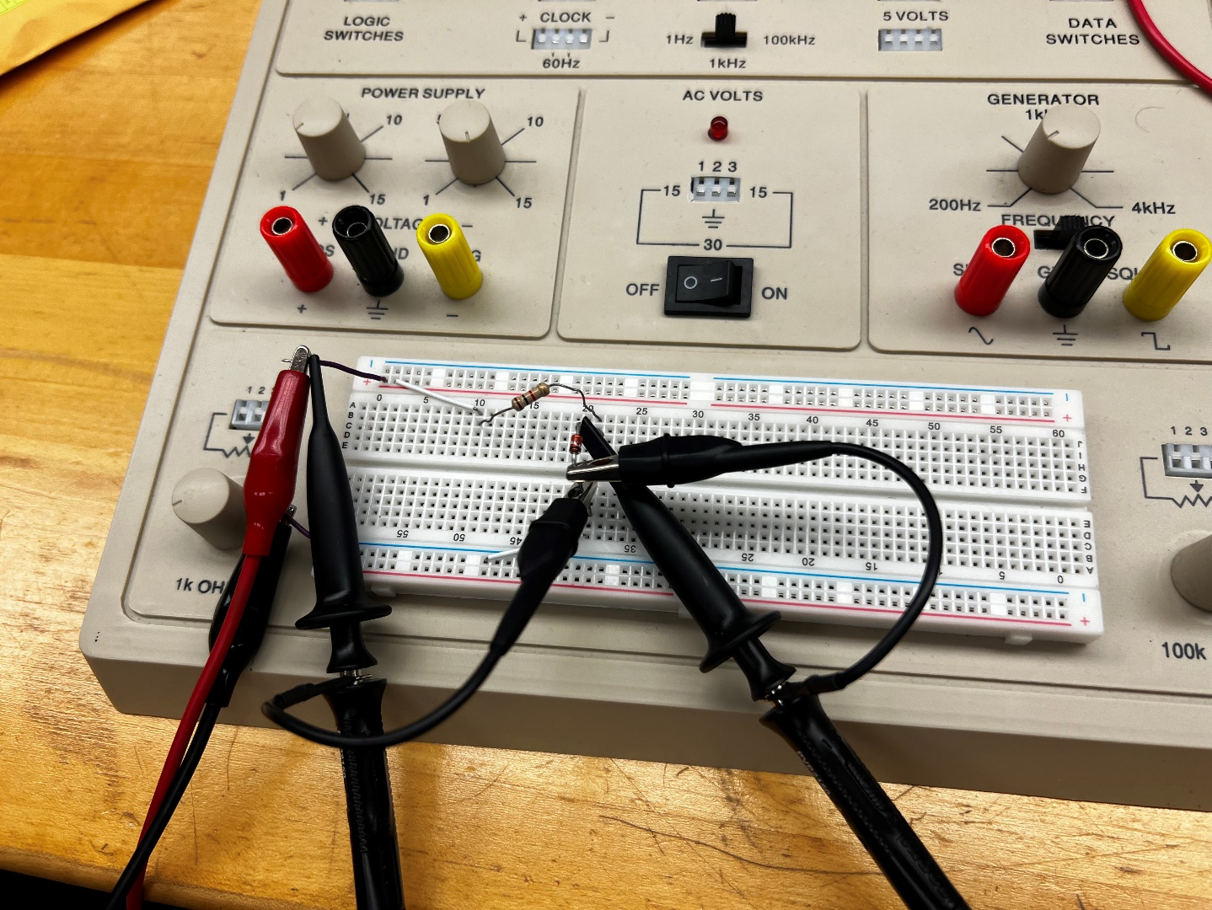

*Figure 10 - Part 2 Bench Construction of Voltage Limiter Circuit 2 (forward-bias)*

Comparing these findings with the former simulation theoretical observations yields a similar result and therefore proving this understanding of Zener diodes and voltage limiting circuits.

One circuit remains for construction, that being a two Zener diode voltage limiting circuit, which constructed in Multisim looks as follows:

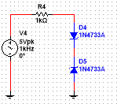

*Figure 11 - Part 2 Multisim Construction of Voltage Limiter Circuit 3 (Two Zener diodes in opposing bias)*

Now constructing on the bench:

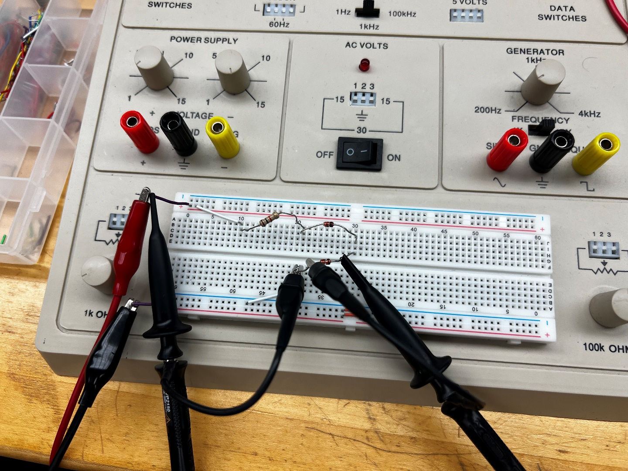

*Figure 12 - Part 2 Bench Construction of Voltage Limiter Circuit 3 (Two Zener diodes in opposing bias)*

And the resulting waveform:

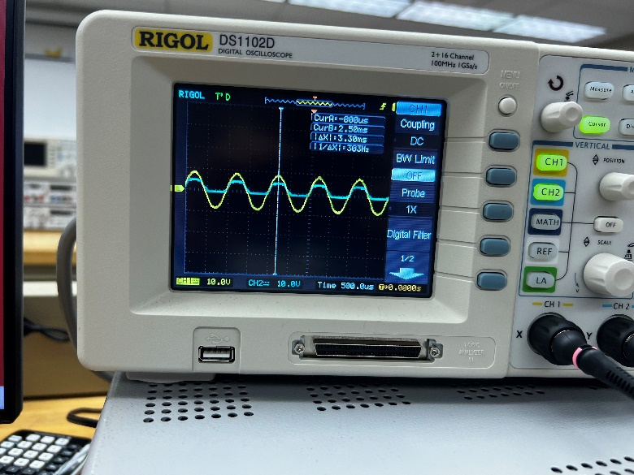

*Figure 13 - Part 2 Circuit 3 Waveform Result (Two Zener diodes in opposing bias)*

Below is a graphical comparison of the data found in part one to determine whether the theory presented in this lab is accurate with its findings:

*Figures 14 and 15 – Graph Comparisons of Part 1 Table 1*

Finally, for certification purposes, below the instructor sign-off can be found. As a reminder, this signature is obtained by either the course instructor or a certified lab assistant to ensure proper results are being obtained.

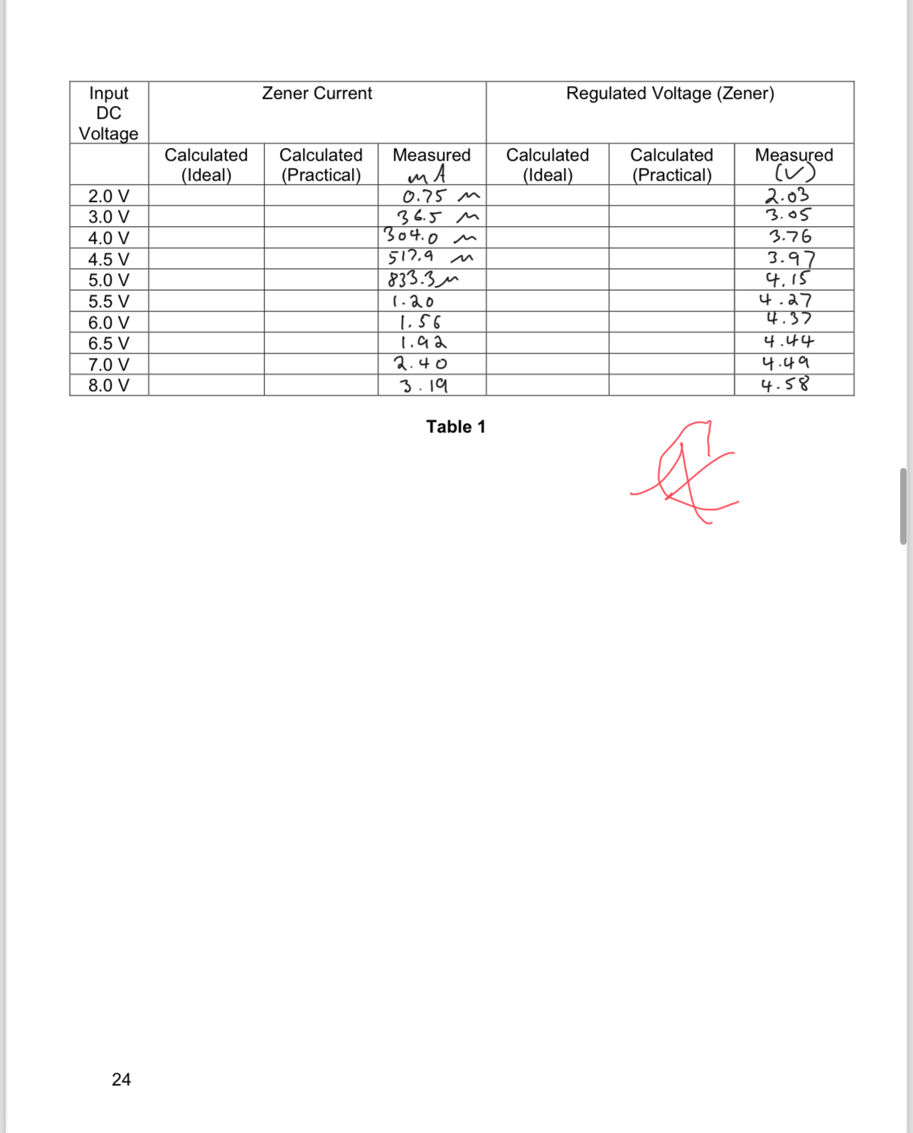

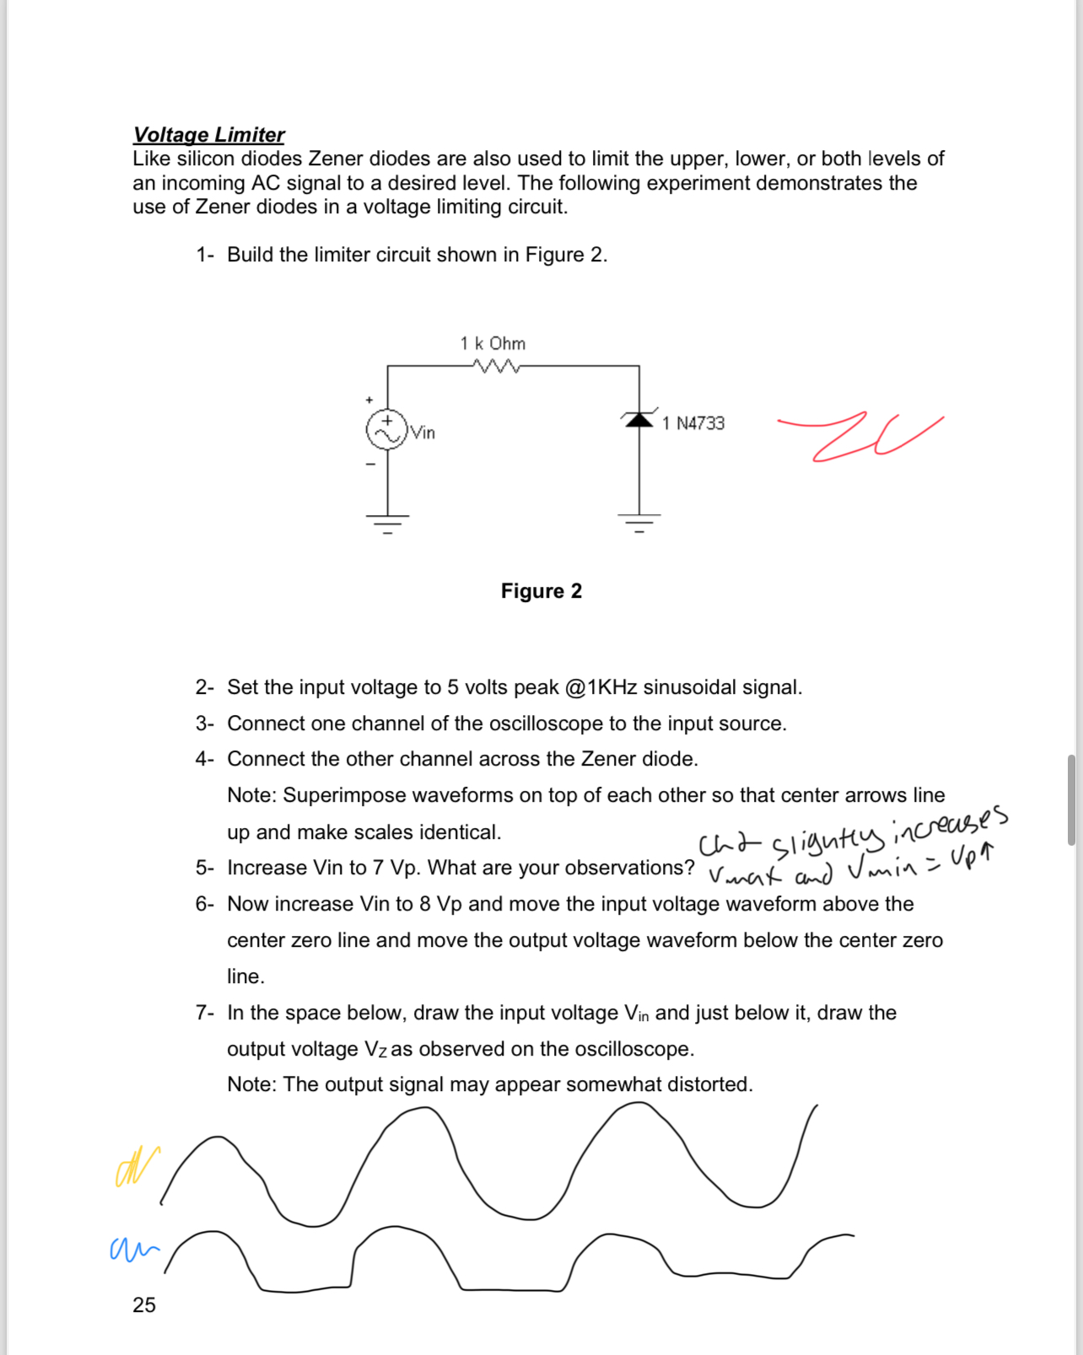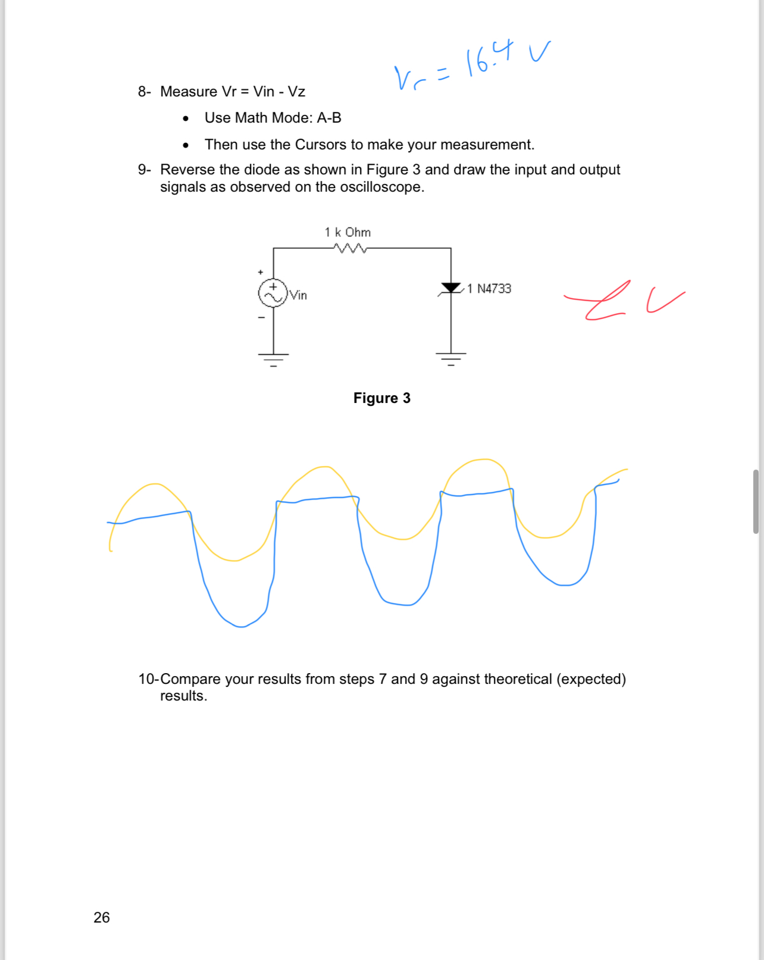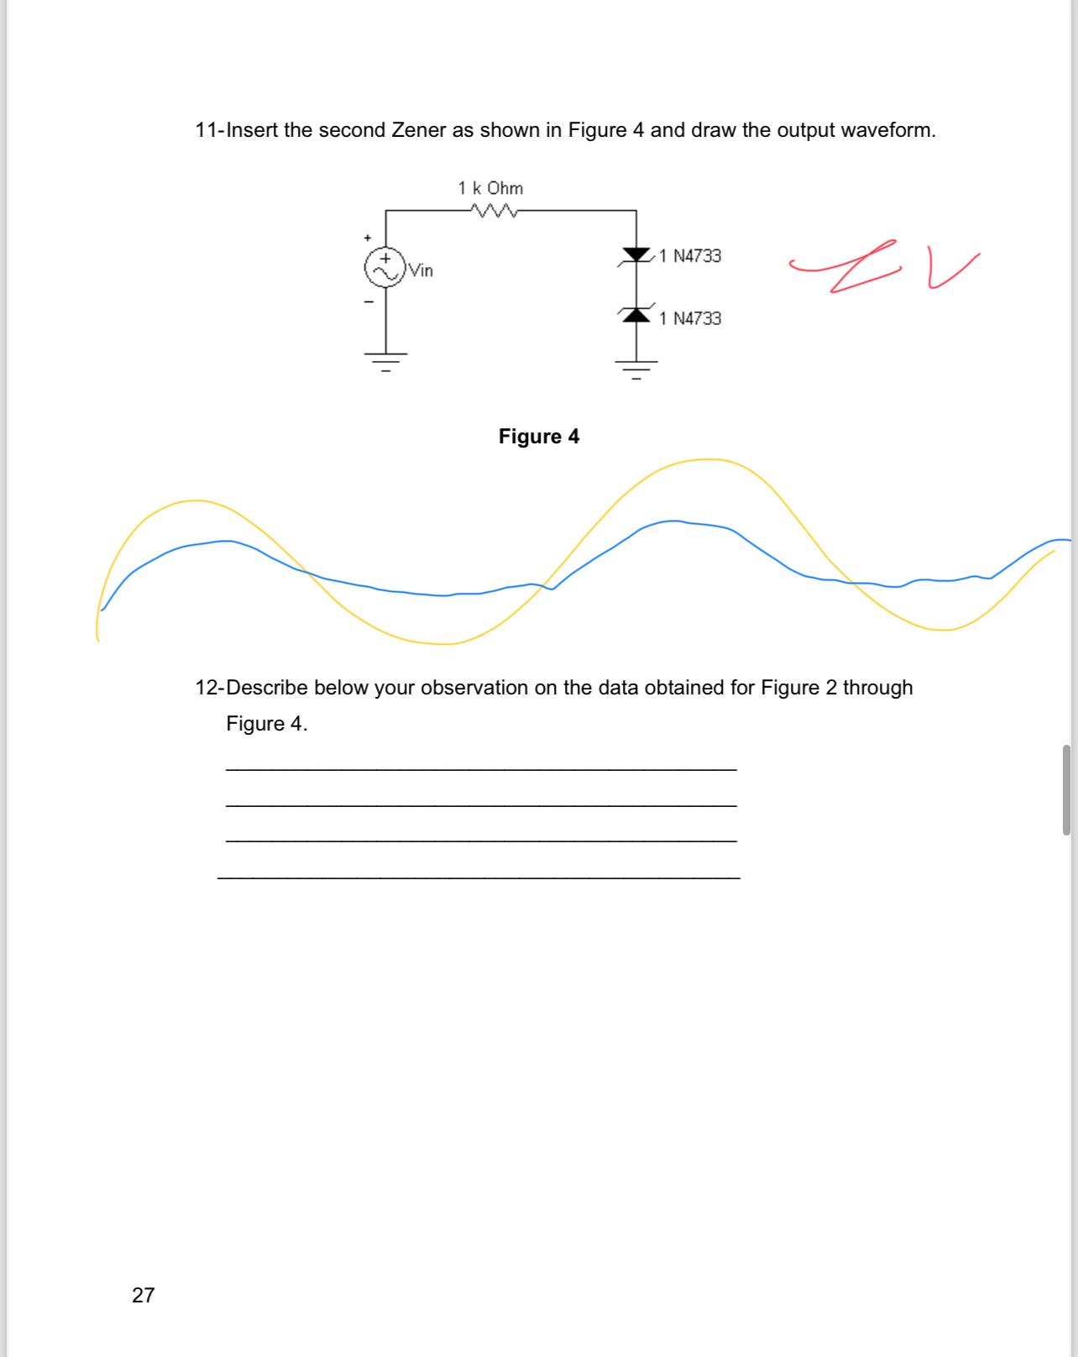

*Figures 16 through 19 - Supervisor Approval of Lab Work*

**Conclusion:**

The objective of this lab is to obtain an understanding and visualization of the behavior and purposes of Zener diodes in a general capacity as well as their role in a voltage limiting circuit. This objective was met successfully as is indicated in our matching data found in our comparison graphs at the end of the report. Here we can learn that a Voltage limiting circuit limit and AC signal to a specific DC voltage point, effectively specifically converting the signal. Zener diodes can also be used in forward bias in the same way a normal diode is used. We also learn that placing two Zener diodes in opposing bias against each other in a single circuit essentially act as a voltage clipper. If this lab were to be conducted again, it would be pertinent to include additional circuits, more components in those circuits, and potentially begin to look into other sorts of diode based circuits such as those with tunnel diodes, and their effects on Zener diode based circuits.